Prayer of Remembrance
Oración de Recuerdo



Leader :
We would like to welcome everyone here this evening. It is our tradition that November is the month when we remember collectively our beloved dead. We know that they are with us today and that even as we pray for them, they are already praying for us. Our love for them continues and their love for us does, too. Let us sit for a few moments in silence and be present to that love which is with us.

Hymn: All are invited to sing: “Christ Be Our Light” versus 1&2
Himno: Todos invitados a cantar: “Cristo Sea Nuestra Luz” versos 1 y 2

Reader: John 8:12
Lector: Juan 8:12
“Jesus spoke to them again saying, ‘I am the light of the world. Whoever follows me will not walk in darkness, but will have the light of life.’ ”
“Jesús les hablo de Nuevo diciendo: ‘yo soy la luz del mundo. El que me sigue no caminara en tinieblas, sino que tendrá luz y vida.’”

Prayer/Oración:
Divine Light, Radiant Holy One, Light of all lights, we call upon our beloved one’s to be with us this night. Help us all to follow you. In the warmth of Your Light, help us to see how each one brought a touch of your light into our world.
Luz Divina, Santísima Luz, Luz de todas luces, hacemos un llamamiento a nuestros seres queridos que estén con nosotros esta noche. Ayúdanos a seguirte. En la calidez de Tu Luz, ayúdanos a ver como cada unos trajeron un poco de Tu Luz a nuestro mundo.

We invite the participants to come up one at a time and place your photo or momento on the altar. Light the candle in front of your photo from the one that is already lit,
Share the name, date of death and relationship to your loved one.
Los invitamos que pasen uno por uno y que coloquen una foto o un recordatorio de su ser querido en el altar. Favor de iluminar una vela delante de la foto o recordatorio, tomando la llama de unas de las otras velas que estén iluminadas.
Comparte el nombre, aniversario de la muerte y la relación de su ser querido.

Questions for Reflection:
Preguntas de Reflección:

- As you remember your loved one who has died, recall a time
or times that person was a source of light for you.
Mientras se recuerda de su ser querido, recuérdese de un momento
cuando esa persona fue una fuente de luz para Usted.

- Allow yourself to sit quietly with the memories that come to you.
Permítase de sentarse en silenció con las memorias que les venga a mente.

- Offer an expression of gratitude for the light this person has brought to your life.
Ofrezca una expresión de gratitud por la luz que esta persona le trajo a su vida.

Response/Respuesta: After each person has an opportunity to share a memory, all respond:
“the light shines in the darkness, and the darkness could not overpower.”
Después que cada persona tenga la oportunidad de compartir una memoria, todos respondemos: “la luz brilla en la oscuridad, y la oscuridad no puede dominar”

Reading:

The resurrection of Jesus is witness to God’s triumph over pain and death.
Because of the resurrection we can hope that we, too, will rise again;
that everything dark will turn to light.
We must never forget that God’s harmony reigns supreme.
Even when we do not experience God’s light, it is always our hope.
Indeed, to be alive and vital is to believe that
the golden flowers of God are in bud,
that there is still the invitation to grow and nurture hearts.”

Grace Abounds: Edith Prendergast, RSC

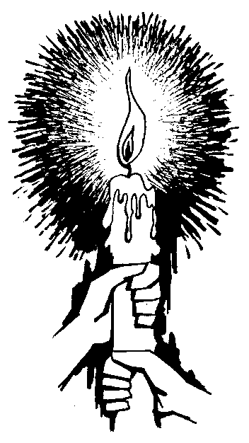

Intercessions of Light

Response: “the light shines in the darkness, and the darkness could not overpower.”
Respuesta: “la luz brilla en la oscuridad, y la oscuridad no puede dominar”

Leader: God of Light hear our prayer and guide us in the darkness of our lives:
Líder: Dios de Luz oye nuestras oraciones y guíñennos en la oscuridad de nuestras vidas:

For those who died due to violence and brutal aggression, we invite each of you to name your loved ones: ______________________________
may they know your deep abiding peace and rest in your loving embrace.
Por aquellos quienes fallecieron por la violencia y agresión brutal, los invitamos que nombren sus seres queridos: _________________________ que obtengan una paz profunda y que descansen en su abraso amoroso.
(Response/Respuesta)

For those who struggle to reconcile their anger and feel lost in darkness and alienation, may your Light guide them to know your constant presence in their pain and bring them healing.
Por aquellos que luchan para reconciliar su enfado y se sienten perdidos en la oscuridad y alejados, que su Luz los guille para que reconozcan Su presencia contante en el dolor y que les traiga sanación.
(Response/Respuesta)

For those who fear they may be overpowered by the darkness of discouragement and despair, may they experience the radiance of your inner Light.
Por aquellos quienes teman que no puedan dominar la oscuridad del desaliento y la desesperación, que reciban el esplendor de Tu Luz interna.
(Response/Respuesta)

We pray for ourselves Lord, that your Light and Love heals us, and fill our minds and hearts with peace.
Señor, oramos por nosotros, que Tu Luz y Amor nos sane y que nos llene nuestras mentes y corazones con paz.
(Response/Respuesta)

That the dawn of each new day may be a sign for us to trust in you, and help us to believe that your light is radiant within us.

Que el amanecer de cada nuevo día sea un símbolo para poder confiar in Ti y que nos ayude a creer en que Tu luz sea brillante adentros de nosotros.
(Response/Respuesta)

For what else shall we pray…
Por cuales otras cosas oremos…
(Response/Respuesta)

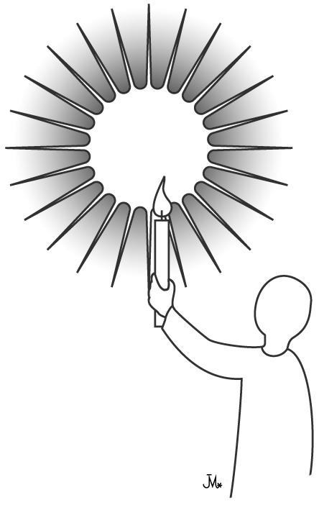
Leader:
Lider:
We pray and unite with all our loved ones
on their journey into God as we say,
“Our Father……”
Oramos y nos unimos con nuestros seres queridos
en sus hornadas hacia Dios
“Padre Nuestro…”

Closing Prayer/Oración de Clausura:

God of Mercy and light,
Make us holy….
Becoming ever more our companion,
our living light,
and a guide that we may always hear and follow.

Let us go wherever you lead us,
in darkness or light,
to the splendor of Mount Tabor or the foot of the cross.
It makes no difference as long as you are with us,
and we will always be able to hear you when you speak to us.
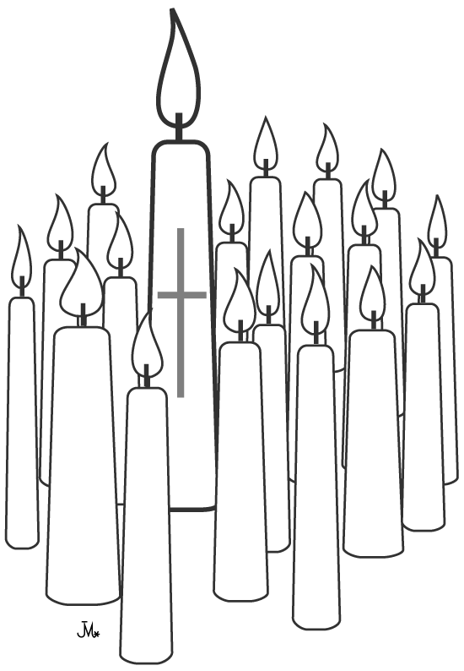
Amen

(adapted from Elizabeth Leseur)

Hymn: “Christ Be Our Light” versus 4&5
Himno: “Cristo Sea Nuestra Luz” versos 4 y 5

Please wait in silence until service has ended.
Favor de esperar en silencio hasta el fin del servicio.

